NAME………………………………………ADM NO: …………….CLASS……………

231/3

BIOLOGY PAPER 3 PRACTICAL

MARCH/APRIL 2023 TIME: 1 ¾ HOURS

MOKASA 1 JOINT EVALUATION EXAMINATIONS

*Kenya Certificate of Secondary Education*

231/3

BIOLOGY PAPER 3 PRACTICAL

MARCH/APRIL,2023 TIME: 1 ¾ HOURS

INSTRUCTIONS TO CANDIDATES

* Write your Name, Class and Adm No. in the spaces provided above
* Answer ALL the questions in the spaces provided

FOR EXAMINERS USE ONLY

Marking scheme

|  |  |  |
| --- | --- | --- |
| QUESTION | MAXIMUM SCORE | CANDIDATES SCORE |
| 1 | 14 |  |
| 2 | 12 |  |
| 3 | 14 |  |
| TOTAL | 40 |  |

1. You are provided with a fruit labelled K. You are required to cut transversely through the middle section of the fruit using the knife provided. You are to use one half of the fruit for question 1 and preserve the other half for **question 2**.
   1. Cut a 1cm slice from one half of the fruit and remove the peel. Place the soft part of the fruit in a mortar and mash it into a fine paste using a pestle.

Add 10 ml of distilled water into the paste and stir the mixture, then transfer it into a beaker.

* 1. Using the reagents provided, carry out appropriate food tests on the mixture as you fill in the table below: (12 marks)

|  |  |  |  |
| --- | --- | --- | --- |
| Food  substance | Procedure | Observation | Conclusion |
| starch | To 2ml test material in test tube;add 3 drops of iodine solution;shake | Blue-black colour; | Starch present; |
| Reducing sugars; | To 2ml of test material in test tube;add equal amounts of Benedicts solution;heat in water bath; | Green/yellow/orange/brown colour; | Reducing sugars present; |
| Proteins; | To 2ml of test material;add equal amounts of NaOH;add CuSO4  dropwise;shaking after each drop; | Blue colour persists; | Proteins absent; |

* 1. Name the deficiency disease in children that may result from feeding them on specimen K alone especially after weaning. (1mk)

…………………Kwashiokor;…………………………………………………………………

* 1. Identify the hormone responsible for ripening of the specimen K above. (1mk)

………………………………Ethylene/ethene;………………………………………………

1. Using specimen K and M provided;
   1. Identify the types of fruits and give reasons (4mks)

|  |  |
| --- | --- |
| Specimen | Reason |
| K Berry; | Succulent/fleshy(pericarp); |
| M Cypsela; | Persistent calyx; |

* 1. State the mode of dispersal of specimen M and give a reason (2mks)

Mode of dispersal…Animal;………………………………………………………………………

Reason…………………………………………………………………………………………

… presence of hooks;(to stick onto animal’s fur/hair)

* 1. State and explain how fruit K is formed (2mks) Formed by parthenocarpy; ovary changes to fruit without fertilization
  2. 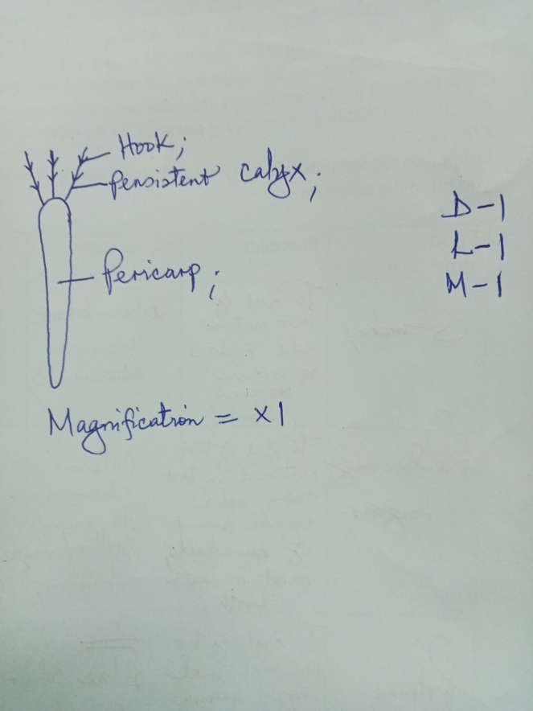Draw and label fruit M (3mks)
  3. When a piece of specimen K was placed in hydrogen peroxide solution, bubbles were produced. State the physiological process that is similar to it in human that was being investigated (1mk)

………………Detoxification;…………………………………………………………………

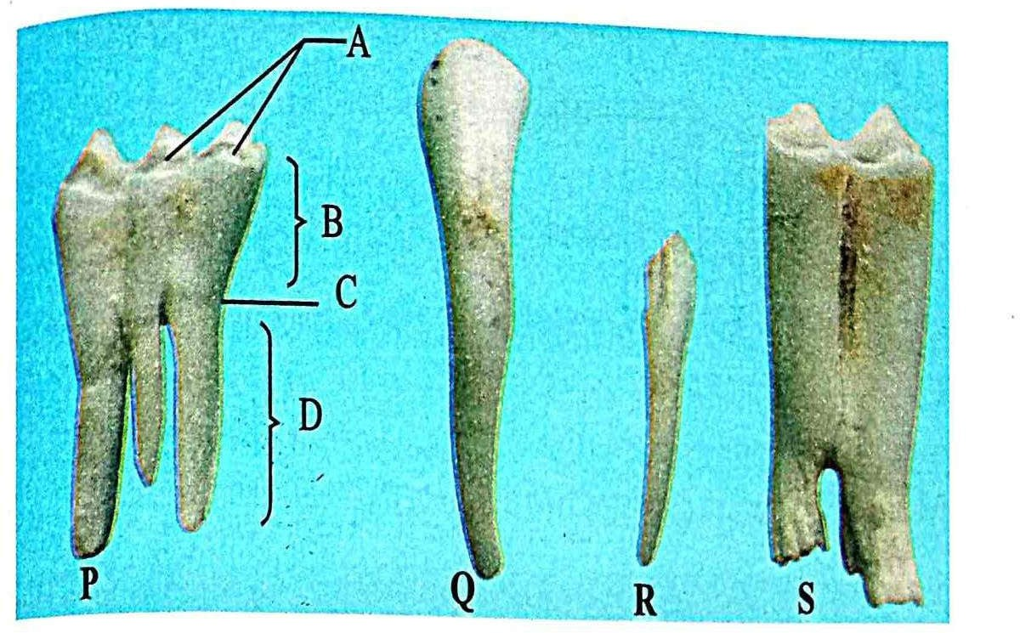3.(a)You are provided with photographs of specimens labeled P, Q, R and S which were obtainedfrom the same animal. Examine them and answer the questions that follow.

* + 1. With a reason identify P and Q. (4mks) P

*……molar;………………………………………………*…………………………… Reason …presence of three roots ;

Q …incisor;

Reason …chisel shaped/has one root;

* + 1. Using observable features only state.
       1. One similarity between specimen Q and R. (1mark)

……………………………………………………………………………………

…………One root; …………………………………

* + - 1. One difference between specimen R and S. (1mark)

|  |  |
| --- | --- |
| **R** | **S** |
| **One root;** | **Two/three roots;** |
| **Lacks cusps/ridges;** | **Has cusps/ridges;** |
| **Smaller/narrower crown;** | **Broader/wider crown;** |

**(Mark first 1 correct)**

* + - 1. Explain how specimen S is adapted for its functions. (1mks) Has three/two roots for anchorage; (owtte)

s

Ridges/cusps;for crushing/grinding;

Wider surface area;for chewing and grinding; (any 1)

(b)On specimen P name the parts labeled A and B (2mks)

1. 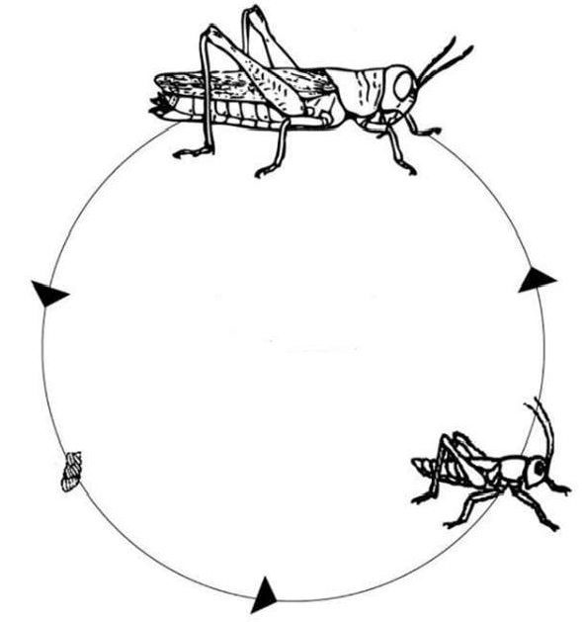The diagram below shows a process that takes place in some insects.Study it and answer the questions that follow.
   1. Identify the life cycle above (1mk)

………………Incomplete metamorphosis;……………

* 1. Name two hormones that control the process (2mks) Juvenile hormone;

Ecdysone hormone; (rej moulting hormone) moulting stimulating hormone;

* 1. Explain the importance of the phenomenon to organisms where it occurs? (2mks) Organisms can occupy different ecological niche;(reducing competition)

Allows more time for development of structures/ organs ;.